**PIZZA SALE SQL QUERIES**

1. **KPI’S:**
2. **Total Revenue:**

**SELECT SUM(total_price) AS Total_Revenue FROM pizza_sales;**

***Output:***

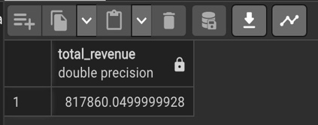

1. **Average Order Value:**

**SELECT SUM(total_price) / COUNT(DISTINCT order_id) AS Avg_Order_Value FROM pizza_sales;**

***Output:***

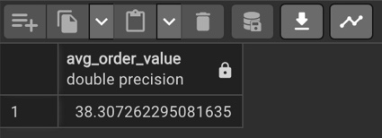

1. **Total Pizzas Sold:**

**SELECT SUM(quantity) AS Total_Pizza_Sold FROM pizza_sales;**

***Output:***

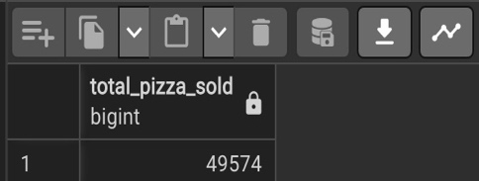

1. **Total Orders:**

**SELECT COUNT(DISTINCT order_id) AS Total_Orders FROM pizza_sales;**

***Output:***

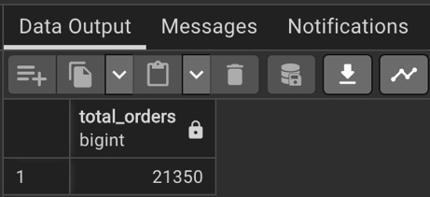

1. **Average Pizzas per Order:**

**SELECT CAST(CAST(SUM(quantity) AS DECIMAL (10,2)) /**

**CAST(COUNT(DISTINCT order_id) AS DECIMAL (10,2)) AS DECIMAL (10,2))**

**AS Avg_Pizzas_Per_Order**

**FROM pizza_sales;**

***Output:***

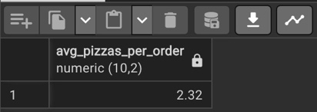

1. **Hourly Trend For Total Pizzas Sold:**

**SELECT EXTRACT(HOUR FROM order_time) AS order_hour, SUM(quantity) AS Total_Pizzas_Sold from pizza_sales**

**GROUP BY EXTRACT(HOUR FROM order_time)**

**ORDER BY EXTRACT(HOUR FROM order_time);**

***Output:***

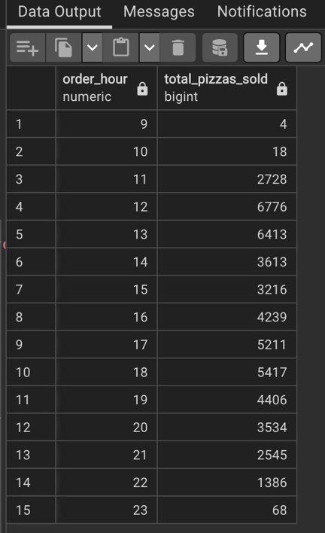

1. **Hourly Trend For Total Pizzas Sold:**

**SET datestyle = 'ISO, DMY';**

**SELECT**

**TO_CHAR(to_date(order_date, 'DD-MM-YYYY'), 'IYYY') AS Order_Year,**

**TO_CHAR(to_date(order_date, 'DD-MM-YYYY'), 'IW') AS Week_Number,**

**COUNT(DISTINCT order_id) AS Total_Orders**

**FROM pizza_sales**

**GROUP BY**

**TO_CHAR(to_date(order_date, 'DD-MM-YYYY'), 'IYYY'),**

**TO_CHAR(to_date(order_date, 'DD-MM-YYYY'), 'IW')**

**ORDER BY**

**TO_CHAR(to_date(order_date, 'DD-MM-YYYY'), 'IYYY'),**

**TO_CHAR(to_date(order_date, 'DD-MM-YYYY'), 'IW');**

***Output:***

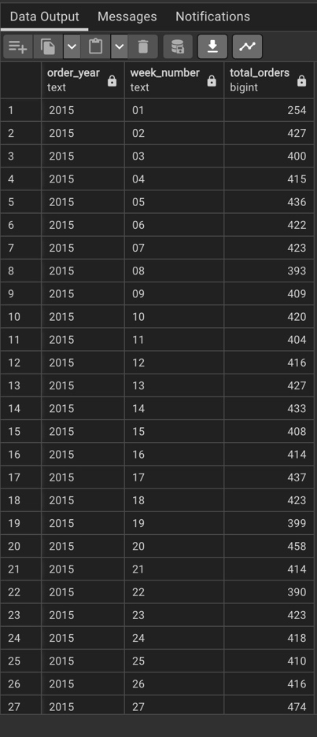 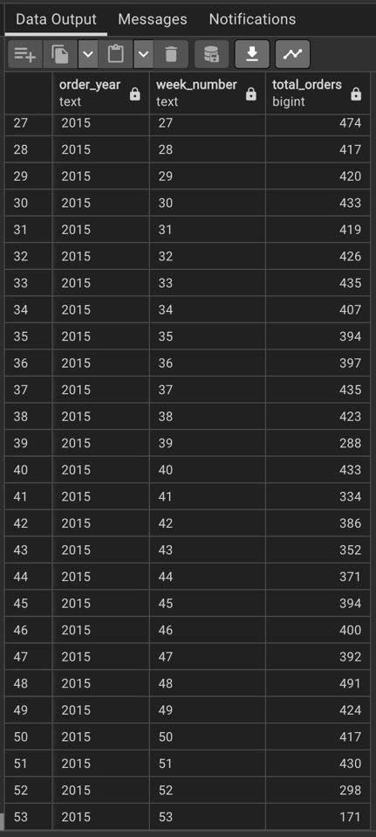

1. **Percentage of Sales by Pizza Category:**

**SELECT pizza_category, SUM(total_price) AS Total_Sales,**

**SUM(total_price) * 100 / (**

**SELECT SUM(total_price) FROM pizza_sales**

**) AS PCT_Sales**

**FROM pizza_sales**

**GROUP BY pizza_category;**

***Output:***

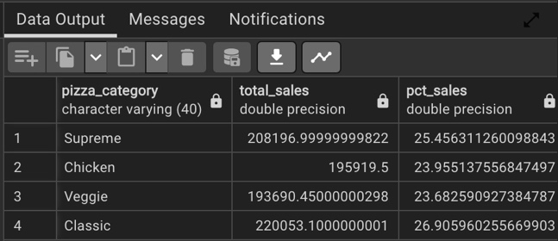

1. **Percentage of Sales by Pizza Size:**

**SELECT pizza_size,**

**CAST(SUM(total_price) AS DECIMAL(10, 2)) AS Total_Sales,**

**CAST(SUM(total_price) * 100 / (**

**SELECT SUM(total_price) FROM pizza_sales) AS DECIMAL(10, 2)) AS PCT_Sales**

**FROM pizza_sales**

**GROUP BY pizza_size**

**ORDER BY PCT_Sales DESC;**

***Output:***

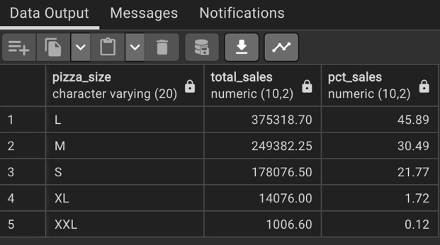

**(for quarter)**

**SELECT pizza_size,**

**CAST(SUM(total_price) AS DECIMAL(10, 2)) AS Total_Sales,**

**CAST(SUM(total_price) * 100 / (**

**SELECT SUM(total_price) FROM pizza_sales**

**WHERE EXTRACT(QUARTER FROM order_date::date) = 1**

**) AS DECIMAL(10, 2)) AS PCT_Sales**

**FROM pizza_sales**

**WHERE EXTRACT(QUARTER FROM order_date::date) = 1**

**GROUP BY pizza_size**

**ORDER BY PCT_Sales DESC;**

***Output:***

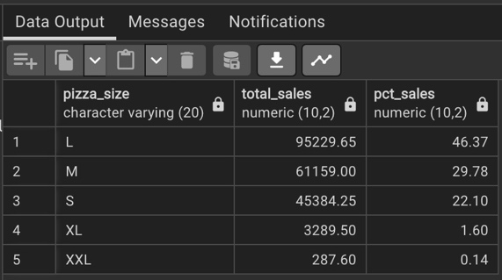

1. **Top 5 Best Sellers by Revenue:**

**SELECT pizza_name,**

**SUM(total_price) AS Total_Rev**

**FROM pizza_sales**

**GROUP BY pizza_name**

**ORDER BY Total_Rev DESC**

**LIMIT 5;**

***Output:***

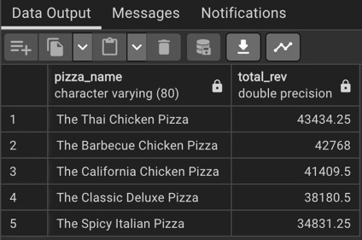

1. **Bottom 5 Best Sellers by Revenue:**

**SELECT pizza_name,**

**SUM(total_price) AS Total_Rev**

**FROM pizza_sales**

**GROUP BY pizza_name**

**ORDER BY Total_Rev ASC**

**LIMIT 5;**

***Output:***

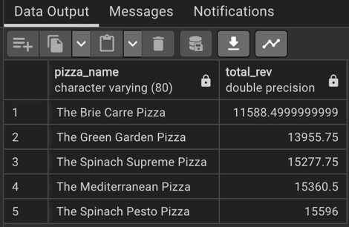

1. **Top 5 Best Sellers by Total Quantity:**

**SELECT pizza_name,**

**SUM(quantity) AS Total_Qty**

**FROM pizza_sales**

**GROUP BY pizza_name**

**ORDER BY Total_Qty DESC**

**LIMIT 5;**

***Output:***

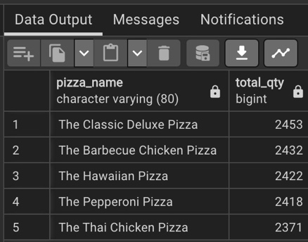

1. **Top 5 Best Sellers by Total Quantity:**

**SELECT pizza_name,**

**SUM(quantity) AS Total_Qty**

**FROM pizza_sales**

**GROUP BY pizza_name**

**ORDER BY Total_Qty ASC**

**LIMIT 5;**

***Output:***

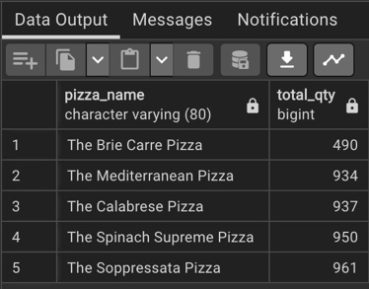

1. **Top 5 Best Sellers by Total Quantity:**

**SELECT pizza_name,**

**COUNT(DISTINCT order_id) AS Total_Ord**

**FROM pizza_sales**

**GROUP BY pizza_name**

**ORDER BY Total_Ord DESC**

**LIMIT 5;**

***Output:***

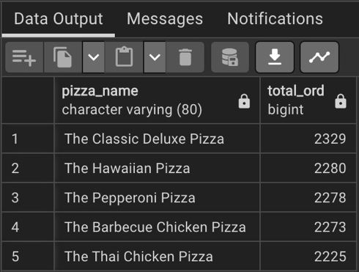

1. **Bottom 5 Best Sellers by Total Quantity:**

**SELECT pizza_name,**

**COUNT(DISTINCT order_id) AS Total_Ord**

**FROM pizza_sales**

**GROUP BY pizza_name**

**ORDER BY Total_Ord ASC**

**LIMIT 5;**

***Output:***

